GREEK NAME | ROMAN NAME | CHARACTERISTICS | SYMBOL(S)
Zeus (ZOOS) | Jupiter (JOO-pit-er) | King of the gods. He is sometimes angry at the behavior of gods and people, but he can also be a gentle and caring ruler. he is particularly fond of beautiful women, regardless of whether they are goddesses or mortals. | thunderbolt, shield, oak tree
Poseidon (poh-SIE-don) | Neptune (NEP-toon) | Zeus's brother, God of the ocean and the earthquakes. He is often distinguished in art by the fisherman's trident that he carries-a three pronged spear. | trident, horse, bull
Hera (HEE-ruh) | Juno (Joo-noh) | Zeus's wife. Queen of the gods, guardian of marriage. She is a great lady and diplomat. Though she is often jealous and nags her husband, she can also be a tender and loving wife. | peacock, cow
Athena (uh-THEEN-uh) | Minerva (min-ER-vuh) | Daughter of Zeus (born, it is said, from his brain, when he had a bad headache). She is the goddess of wisdom and war, patriotism, and good citizenship. She is the protector and namesake of the city of Athens. | owl, shield, olive tree
Apollo [uh-PAW-loh] | Apollo | Son of Zeus. God of poetry, music, medicine and light. He is associated with the sun. | crow, dolphin, laurel, lyre
Artemis [AR-tim-is] | Diana [die-AN-uh] | Apollo's twin sister. Goddess of hunting and of wild things. She is associated with the moon. She is sometimes called "Cynthia." | stag, crescent, moon, cypress
Hades [HAY-deez] | Pluto [PLU-toe] | God of the underworld. | helmet, metal jewels
Ares [Air-eez] | Mars [MARZ] | Son of Zeus. Terrible god of war. | vulture, dog
Hephaestus [hee-FES-tuhs] | Vulcan [VUL-kan] | Son of Zeus and Hera, the lame blacksmith god of fire. | fire, blacksmith's hammer
Aphrodite [af-roh-DIE-tee} | Venus [VEE-nus] | The wife of Hephaestus, she is the goddess of love and beauty. She is said to have been born of the sea foam. Her son, Eros [AIR-ohss] (the Roman Cupid [KU-pid]), shoots arrows which cause men and women to fall in love. Another son, Aeneas [ee NEE-uhs], is a mortal man, considered to be the ancestor of the Romans. | dove, goose, sparrow, myrtle
Hestia [HES-tee-uh] | Vesta [VES-tuh] | Zeus's sister. Goddess of home and hearth. | hearth
Demeter [dee-MEE-ter] | Ceres [SEER-eez] | Zeus's sister. She is the very important goddess of grain and agriculture. She is a kind of bond between heaven and earth. | wheat

Monsters to Know:
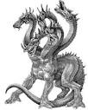
Medusa Kraken Cerberus Hydra

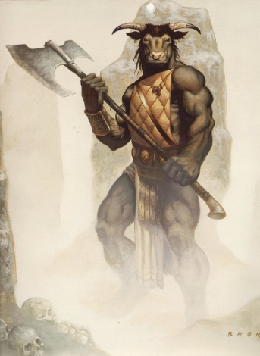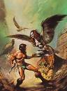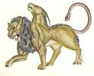
Minotaur Harpy Chimera Cyclopes

