[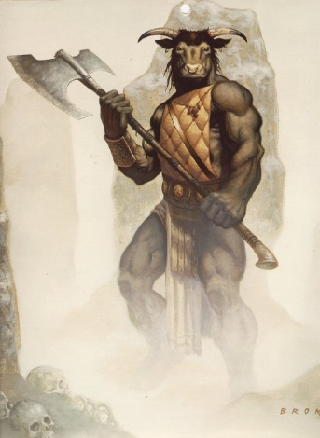](http://www.fantasygallery.net/brom) [](http://www.google.com/imgres?imgurl=http://4.bp.blogspot.com/_HlZdRg95SX0/TQuieIIshdI/AAAAAAAAAHA/k1_SNCyqKpY/s1600/medusa+%25283%2529%255B1%255D.jpg&imgrefurl=http://zawa.villerio.us/medusa+tattoos+ithaca.html&usg=__BtgxPVXaEvFtobfHt9HUeiFRzwY=&h=432&w=429&sz=24&hl=en&start=15&zoom=1&itbs=1&tbnid=G_sqAZMeGmS5gM:&tbnh=126&tbnw=125&prev=/images?q=medusa&hl=en&safe=active&gbv=2&tbs=isch:1&ei=Hbp3TafnJ4rCsAOz5ZzEBA) [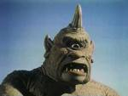](http://www.google.com/imgres?imgurl=http://images.wikia.com/olympians/images/4/43/Cyclops_picture_of_head.jpg&imgrefurl=http://www.kmle.co.kr/search.php?Search=cyclopes&usg=__1nOFiryIcSDgXxIZf1aFLzqCEIM=&h=768&w=1024&sz=187&hl=en&start=30&zoom=1&itbs=1&tbnid=yava-IZbgYkVgM:&tbnh=113&tbnw=150&prev=/images?q=cyclopes&start=20&hl=en&safe=active&sa=N&gbv=2&ndsp=20&tbs=isch:1&ei=XLp3TdqCMISqsAPVi4HKBA)

**Label the monsters of mythology**: hydra, chimera, Cyclops , Minotaur, cerberus, charybdis, kraken, harpy, Medusa

____________________ ______________________ ________________________

[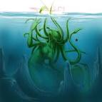](http://www.google.com/imgres?imgurl=http://fc04.deviantart.com/fs14/f/2006/356/2/e/WIP__Kraken_by_DaKraken.jpg&imgrefurl=http://ravenswingpoetry.com/2008/05/16/kraken/&usg=__3wJUIYxmbb90c1r-PiBLAnNEUgM=&h=800&w=800&sz=50&hl=en&start=15&zoom=1&itbs=1&tbnid=mPMk0QLdQXD-jM:&tbnh=143&tbnw=143&prev=/images?q=kraken&hl=en&safe=active&gbv=2&tbs=isch:1&ei=k7p3Tdy_IYzmsQPqwpi7BA) [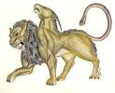](http://www.google.com/imgres?imgurl=http://1.bp.blogspot.com/_QrnebW0mqo8/TMbK9LZ4n1I/AAAAAAAAAJ8/ndYTdYd4lNQ/s400/chimera3sm.jpg&imgrefurl=http://abbysinyem.blogspot.com/2010/10/chimera.html&usg=__XpVK7PuxWAyc8m2QFIA1_m58J0c=&h=317&w=389&sz=35&hl=en&start=15&zoom=1&itbs=1&tbnid=0trdzBJSTp5S2M:&tbnh=100&tbnw=123&prev=/images?q=chimera&hl=en&safe=active&sa=N&gbv=2&ndsp=20&tbs=isch:1&ei=Fbt3TdjADYnAsAOJpNXBBA) [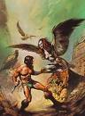](http://www.google.com/imgres?imgurl=http://www.rstolley.com/Harpie.jpg&imgrefurl=http://hoverfrog.wordpress.com/category/thursday-thirteen/&usg=__lapIbeVAGBjhOOTBAzAQTtpWVTg=&h=500&w=369&sz=23&hl=en&start=6&zoom=1&itbs=1&tbnid=79JNSbvHG64D8M:&tbnh=130&tbnw=96&prev=/images?q=harpie&hl=en&safe=active&gbv=2&tbs=isch:1&ei=Ybt3TeG2MY-0sAPjoIHBBA)

_________________________ __________________________ _______________________

[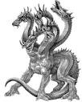](http://www.google.com/imgres?imgurl=http://www.snapstream.com/images/community/hydra/Hydra.bmp&imgrefurl=http://www.snapstream.com/Community/Articles/hydra/default.asp&usg=__-EzMUMPhqx5Jsa4c5xkMjvriklA=&h=450&w=361&sz=162&hl=en&start=3&zoom=1&itbs=1&tbnid=IyEqvpADIiy6sM:&tbnh=127&tbnw=102&prev=/images?q=hydra&hl=en&safe=active&gbv=2&tbs=isch:1&ei=lrt3TePwDIn2swPW7YWxBA) [](http://www.google.com/imgres?imgurl=http://blogs.reuters.com/reuters-dealzone/files/2007/12/cerberusallison.jpg&imgrefurl=http://www.bigsoccer.com/forum/blog.php?b=5871&usg=__5SNx85yxU7jHJ6YFvCUcIdWglgk=&h=300&w=300&sz=20&hl=en&start=54&zoom=1&itbs=1&tbnid=8iTmDqA0Jg6TEM:&tbnh=116&tbnw=116&prev=/images?q=greek+mythology+monsters&start=40&hl=en&safe=active&sa=N&gbv=2&ndsp=20&tbs=isch:1&ei=7rt3TfaxL420sAOyvvnDBA) [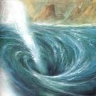](http://www.google.com/imgres?imgurl=http://3.bp.blogspot.com/__2WnMMxTFyE/TP-Qvs87c1I/AAAAAAAAA4g/EKzdOXD85sw/s1600/CharybdisPainting.jpg&imgrefurl=http://bubosblog.blogspot.com/2010/12/odyssey-stop-11.html&usg=__BJlN-S8bAoe8mqKSAOTwoHEe4Ww=&h=600&w=600&sz=101&hl=en&start=1&zoom=1&itbs=1&tbnid=aoe_W-gjQkJ-vM:&tbnh=135&tbnw=135&prev=/images?q=charybdis&hl=en&safe=active&gbv=2&tbs=isch:1&ei=ttZ3TeiOC4LCsAPw0-XBBA)

___________________ ______________________ ____________________________